* **Activity 1:**

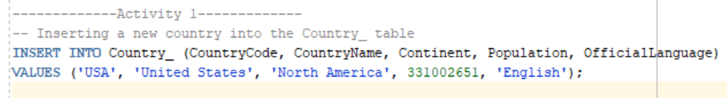Inserting New Rows

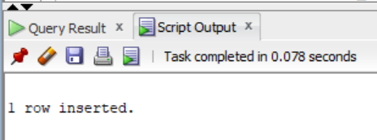OUTPUT: